2. DEVICE DESCRIPTION & PRODUCT SPECIFICATION, INCLUDING VARIANTS & ACCESSORIES
2.1 Descriptive information for the device
(a) Device Description

The -86 Ultra Low temperature Freezer is intended for the storage of Frozen Red Blood Cells in 40% Glycerol at –65°C for up to 10 years; Frozen Rejuvenated Red Blood Cells at –65°C for up to 10 years; Fresh Frozen Plasma at –65°C for up to 10 years. These products are suitable for Vaccine and Pharmaceutical Storage when –50°C to –86°C is determined as an acceptable storage condition. These products should only be used by an authorized and adequately trained personnel.
The –86°C Freezers (refer to Models for the specific model series) described in this manual are intended for the storage of Frozen Red Blood Cells in 40% Glycerol at –65°C for up to 10 years; Frozen Rejuvenated Red Blood Cells at –65°C for up to 10 years; Fresh Frozen Plasma at –65°C for up to 10 years. These products are suitable for Vaccine and Pharmaceutical Storage when –50°C to –86°C is determined as an acceptable storage condition. These products should only be used by an authorized and adequately trained personnel. This unit is not intended for use in classified hazardous locations, nor to be used for the storage of flammable inventory.

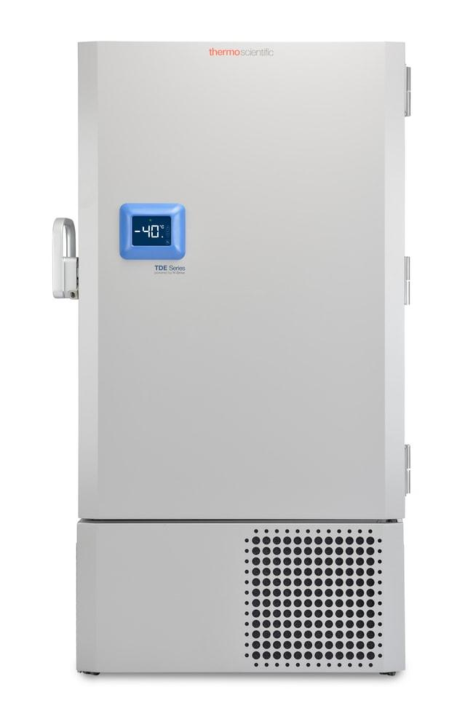

Indications:
No Indications are defined in the Installation and Operation manual. The –86°C Freezers described in this manual are intended for the storage of Frozen Red Blood Cells in 40% Glycerol at –65°C for up to 10 years; Frozen Rejuvenated Red Blood Cells at –65°C for up to 10 years; Fresh Frozen Plasma at –65°C for up to 10 years. These products are suitable for Vaccine and Pharmaceutical Storage when –50°C to –86°C is determined as an acceptable storage condition. These products should only be used by an authorized and adequately trained personnel. This unit is not intended for use in classified hazardous locations, nor to be used for the storage of flammable inventory.
Instructions for Use:
The -86 Ultra Low Temperature Freezer units are intended for use by authorized and adequately trained personnel. These units are not for use by the general public.
Table 1: Various Configurations or Variants of the device
Model | Capacity Cu. (L) | Capacity Cryoboxes (2 in.) | Electrical (voltage, frequency, current)
TDE30086LA | 422 | 300 | 115V, 60 Hz, 1 Phase
TDE30086LD | 422 | 300 | 208-230V, 60 Hz, 1 Phase
TDE30086LV | 422 | 300 | 230V, 50 Hz, 1 Phase
TDE40086LA | 549 | 400 | 115V, 60 Hz, 1 Phase
TDE40086LD | 549 | 400 | 208-230V, 60 Hz, 1 Phase
TDE40086LV | 549 | 400 | 230V, 50 Hz, 1 Phase
TDE50086LA | 682 | 500 | 115V, 60 Hz, 1 Phase
TDE50086LD | 682 | 500 | 208-230V, 60 Hz, 1 Phase
TDE50086LV | 682 | 500 | 230V, 50 Hz, 1 Phase
TDE60086LA | 816 | 600 | 115V, 60 Hz, 1 Phase
TDE60086LD | 816 | 600 | 208-230V, 60 Hz, 1 Phase
TDE60086LV | 816 | 600 | 230V, 50 Hz, 1 Phase

• 2.2 Product specification**\n
-86 Ultra Low temperature Freezer is designed for efficiency. As a result, the series delivers a foundational experience with the reliability and performance needed to protect users work—and the sustainability to meet global compliance. The devices are available in different models, with their features, dimensions, and performance attributes summarized in the table below.
Table 2: Product specification
Model | Temp range (°C) | Capacity (L) | Refrigerant | Connectivity | Power cord specifications | Electrical (voltage, frequency, current) | Product capacity | Interior dimensions D x W x H (cm) | Exterior dimensions D x W x H (cm) | Shipping weight (kg)
TDE30086LA | -50°C to -86°C | 422 | R290 / R170+R290 Mix | RS485/4-20mA output/Dry Contacts | NEMA 5-20 / IEC Cords, 10 ft (3.05 m) | 115V, 60 Hz, 1 Phase | 300 Standard 2" Boxes | 1300 x 719 x 452 mm | 1981 x 978 x 584 mm | 323 kg
TDE30086LD | -50°C to -86°C | 422 | R290 / R170+R290 Mix | RS485/4-20mA output/Dry Contacts | NEMA 6-15P / IEC Cords, 10 ft (3.05 m) | 208-230V, 60 Hz, 1 Phase | 300 Standard 2" Boxes | 1300 x 719 x 452 mm | 1981 x 978 x 584 mm | 323 kg
TDE30086LV | -50°C to -86°C | 422 | R290 / R170+R290 Mix | RS485/4-20mA output/Dry Contacts | Country Dependant plug / IEC Cords, 10 ft (3.05 m) | 230V, 50 Hz, 1 Phase | 300 Standard 2" Boxes | 1300 x 719 x 452 mm | 1981 x 978 x 693 mm | 323 kg
TDE40086LA | -50°C to -86°C | 549 | R290 / R170+R290 Mix | RS485/4-20mA output/Dry Contacts | NEMA 5-20 / IEC Cords, 10 ft (3.05 m) | 115V, 60 Hz, 1 Phase | 400 Standard 2" Boxes | 1300 x 719 x 587 mm | 1981 x 978 x 719 mm | 312 kg
TDE40086LD | -50°C to -86°C | 549 | R290 / R170+R290 Mix | RS485/4-20mA output/Dry Contacts | NEMA 6-15P / IEC Cords, 10 ft (3.05 m) | 208-230V, 60 Hz, 1 Phase | 400 Standard 2" Boxes | 1300 x 719 x 587 mm | 1981 x 978 x 719 mm | 312 kg
TDE40086LV | -50°C to -86°C | 549 | R290 / R170+R290 Mix | RS485/4-20mA output/Dry Contacts | Country Dependant plug / IEC Cords, 10 ft (3.05 m) | 230V, 50 Hz, 1 Phase | 400 Standard 2" Boxes | 1300 x 719 x 587 mm | 1981 x 978 x 826 mm | 312 kg
TDE50086LA | -50°C to -86°C | 682 | R290 / R170+R290 Mix | RS485/4-20mA output/Dry Contacts | NEMA 5-20 / IEC Cords, 10 ft (3.05 m) | 115V, 60 Hz, 1 Phase | 500 Standard 2" Boxes | 1300 x 719 x 732 mm | 1981 x 978 x 864 mm | 333 kg
TDE50086LD | -50°C to -86°C | 682 | R290 / R170+R290 Mix | RS485/4-20mA output/Dry Contacts | NEMA 6-15P / IEC Cords, 10 ft (3.05 m) | 208-230V, 60 Hz, 1 Phase | 500 Standard 2" Boxes | 1300 x 719 x 732 mm | 1981 x 978 x 864 mm | 333 kg
TDE50086LV | -50°C to -86°C | 682 | R290 / R170+R290 Mix | RS485/4-20mA output/Dry Contacts | Country Dependant plug / IEC Cords, 10 ft (3.05 m) | 230V, 50 Hz, 1 Phase | 500 Standard 2" Boxes | 1300 x 719 x 732 mm | 1981 x 978 x 970 mm | 333 kg
TDE60086LA | -50°C to -86°C | 816 | R290 / R170+R290 Mix | RS485/4-20mA output/Dry Contacts | NEMA 5-20 / IEC Cords, 10 ft (3.05 m) | 115V, 60 Hz, 1 Phase | 600 Standard 2" Boxes | 1300 x 719 x 874 mm | 1981 x 978 x 1006 mm | 372 kg
TDE60086LD | -50°C to -86°C | 816 | R290 / R170+R290 Mix | RS485/4-20mA output/Dry Contacts | NEMA 6-15P / IEC Cords, 10 ft (3.05 m) | 208-230V, 60 Hz, 1 Phase | 600 Standard 2" Boxes | 1300 x 719 x 874 mm | 1981 x 978 x 1006 mm | 372 kg
TDE60086LV | -50°C to -86°C | 816 | R290 / R170+R290 Mix | RS485/4-20mA output/Dry Contacts | Country Dependant plug / IEC Cords, 10 ft (3.05 m) | 230V, 50 Hz, 1 Phase | 600 Standard 2" Boxes | 1300 x 719 x 874 mm | 1981 x 978 x 1113 mm | 372 kg

2. DEVICE DESCRIPTION & PRODUCT SPECIFICATION, INCLUDING VARIANTS & ACCESSORIES
2.1 Descriptive information for the device
(a) Device Description

The -86 Ultra Low temperature Freezer is intended for the storage of Frozen Red Blood Cells in 40% Glycerol at –65°C for up to 10 years; Frozen Rejuvenated Red Blood Cells at –65°C for up to 10 years; Fresh Frozen Plasma at –65°C for up to 10 years. These products are suitable for Vaccine and Pharmaceutical Storage when –50°C to –86°C is determined as an acceptable storage condition. These products should only be used by an authorized and adequately trained personnel.
The –86°C Freezers (refer to Models for the specific model series) described in this manual are intended for the storage of Frozen Red Blood Cells in 40% Glycerol at –65°C for up to 10 years; Frozen Rejuvenated Red Blood Cells at –65°C for up to 10 years; Fresh Frozen Plasma at –65°C for up to 10 years. These products are suitable for Vaccine and Pharmaceutical Storage when –50°C to –86°C is determined as an acceptable storage condition. These products should only be used by an authorized and adequately trained personnel. This unit is not intended for use in classified hazardous locations, nor to be used for the storage of flammable inventory.



Indications:
No Indications are defined in the Installation and Operation manual. The –86°C Freezers described in this manual are intended for the storage of Frozen Red Blood Cells in 40% Glycerol at –65°C for up to 10 years; Frozen Rejuvenated Red Blood Cells at –65°C for up to 10 years; Fresh Frozen Plasma at –65°C for up to 10 years. These products are suitable for Vaccine and Pharmaceutical Storage when –50°C to –86°C is determined as an acceptable storage condition. These products should only be used by an authorized and adequately trained personnel. This unit is not intended for use in classified hazardous locations, nor to be used for the storage of flammable inventory.
Instructions for Use:
The -86 Ultra Low Temperature Freezer units are intended for use by authorized and adequately trained personnel. These units are not for use by the general public.
Table 1: Various Configurations or Variants of the device
Model | Capacity Cu. (L) | Capacity Cryoboxes (2 in.) | Electrical (voltage, frequency, current)
TDE30086LA | 422 | 300 | 115V, 60 Hz, 1 Phase
TDE30086LD | 422 | 300 | 208-230V, 60 Hz, 1 Phase
TDE30086LV | 422 | 300 | 230V, 50 Hz, 1 Phase
TDE40086LA | 549 | 400 | 115V, 60 Hz, 1 Phase
TDE40086LD | 549 | 400 | 208-230V, 60 Hz, 1 Phase
TDE40086LV | 549 | 400 | 230V, 50 Hz, 1 Phase
TDE50086LA | 682 | 500 | 115V, 60 Hz, 1 Phase
TDE50086LD | 682 | 500 | 208-230V, 60 Hz, 1 Phase
TDE50086LV | 682 | 500 | 230V, 50 Hz, 1 Phase
TDE60086LA | 816 | 600 | 115V, 60 Hz, 1 Phase
TDE60086LD | 816 | 600 | 208-230V, 60 Hz, 1 Phase
TDE60086LV | 816 | 600 | 230V, 50 Hz, 1 Phase

• 2.2 Product specification**\n
-86 Ultra Low temperature Freezer is designed for efficiency. As a result, the series delivers a foundational experience with the reliability and performance needed to protect users work—and the sustainability to meet global compliance. The devices are available in different models, with their features, dimensions, and performance attributes summarized in the table below.
Table 2: Product specification
Model | Temp range (°C) | Capacity (L) | Refrigerant | Connectivity | Power cord specifications | Electrical (voltage, frequency, current) | Product capacity | Interior dimensions D x W x H (cm) | Exterior dimensions D x W x H (cm) | Shipping weight (kg)
TDE30086LA | -50°C to -86°C | 422 | R290 / R170+R290 Mix | RS485/4-20mA output/Dry Contacts | NEMA 5-20 / IEC Cords, 10 ft (3.05 m) | 115V, 60 Hz, 1 Phase | 300 Standard 2" Boxes | 1300 x 719 x 452 mm | 1981 x 978 x 584 mm | 323 kg
TDE30086LD | -50°C to -86°C | 422 | R290 / R170+R290 Mix | RS485/4-20mA output/Dry Contacts | NEMA 6-15P / IEC Cords, 10 ft (3.05 m) | 208-230V, 60 Hz, 1 Phase | 300 Standard 2" Boxes | 1300 x 719 x 452 mm | 1981 x 978 x 584 mm | 323 kg
TDE30086LV | -50°C to -86°C | 422 | R290 / R170+R290 Mix | RS485/4-20mA output/Dry Contacts | Country Dependant plug / IEC Cords, 10 ft (3.05 m) | 230V, 50 Hz, 1 Phase | 300 Standard 2" Boxes | 1300 x 719 x 452 mm | 1981 x 978 x 693 mm | 323 kg
TDE40086LA | -50°C to -86°C | 549 | R290 / R170+R290 Mix | RS485/4-20mA output/Dry Contacts | NEMA 5-20 / IEC Cords, 10 ft (3.05 m) | 115V, 60 Hz, 1 Phase | 400 Standard 2" Boxes | 1300 x 719 x 587 mm | 1981 x 978 x 719 mm | 312 kg
TDE40086LD | -50°C to -86°C | 549 | R290 / R170+R290 Mix | RS485/4-20mA output/Dry Contacts | NEMA 6-15P / IEC Cords, 10 ft (3.05 m) | 208-230V, 60 Hz, 1 Phase | 400 Standard 2" Boxes | 1300 x 719 x 587 mm | 1981 x 978 x 719 mm | 312 kg
TDE40086LV | -50°C to -86°C | 549 | R290 / R170+R290 Mix | RS485/4-20mA output/Dry Contacts | Country Dependant plug / IEC Cords, 10 ft (3.05 m) | 230V, 50 Hz, 1 Phase | 400 Standard 2" Boxes | 1300 x 719 x 587 mm | 1981 x 978 x 826 mm | 312 kg
TDE50086LA | -50°C to -86°C | 682 | R290 / R170+R290 Mix | RS485/4-20mA output/Dry Contacts | NEMA 5-20 / IEC Cords, 10 ft (3.05 m) | 115V, 60 Hz, 1 Phase | 500 Standard 2" Boxes | 1300 x 719 x 732 mm | 1981 x 978 x 864 mm | 333 kg
TDE50086LD | -50°C to -86°C | 682 | R290 / R170+R290 Mix | RS485/4-20mA output/Dry Contacts | NEMA 6-15P / IEC Cords, 10 ft (3.05 m) | 208-230V, 60 Hz, 1 Phase | 500 Standard 2" Boxes | 1300 x 719 x 732 mm | 1981 x 978 x 864 mm | 333 kg
TDE50086LV | -50°C to -86°C | 682 | R290 / R170+R290 Mix | RS485/4-20mA output/Dry Contacts | Country Dependant plug / IEC Cords, 10 ft (3.05 m) | 230V, 50 Hz, 1 Phase | 500 Standard 2" Boxes | 1300 x 719 x 732 mm | 1981 x 978 x 970 mm | 333 kg
TDE60086LA | -50°C to -86°C | 816 | R290 / R170+R290 Mix | RS485/4-20mA output/Dry Contacts | NEMA 5-20 / IEC Cords, 10 ft (3.05 m) | 115V, 60 Hz, 1 Phase | 600 Standard 2" Boxes | 1300 x 719 x 874 mm | 1981 x 978 x 1006 mm | 372 kg
TDE60086LD | -50°C to -86°C | 816 | R290 / R170+R290 Mix | RS485/4-20mA output/Dry Contacts | NEMA 6-15P / IEC Cords, 10 ft (3.05 m) | 208-230V, 60 Hz, 1 Phase | 600 Standard 2" Boxes | 1300 x 719 x 874 mm | 1981 x 978 x 1006 mm | 372 kg
TDE60086LV | -50°C to -86°C | 816 | R290 / R170+R290 Mix | RS485/4-20mA output/Dry Contacts | Country Dependant plug / IEC Cords, 10 ft (3.05 m) | 230V, 50 Hz, 1 Phase | 600 Standard 2" Boxes | 1300 x 719 x 874 mm | 1981 x 978 x 1113 mm | 372 kg

